S_ALR_87013127 -

Functionality
This transaction gives you a list of the orders. You can also view the details for an order from the order list.
In Product Cost Controlling costs are collected on Product Cost Collectors with order types:
RM01 - PCC for Repetitive Manufacturing
RM01 - PCC for Process orders
CP03 - Planning CO Production Orders
Scenario
This transaction gives you a list of the orders. You can also view the details for an order from the order list.
Requirements
None.

Menu Path | Accounting → Controlling → Product Cost Controlling → Cost Object Controlling → Product Cost by Period → Information System → Object List → S_ALR_87013127 - Order Selection
Transaction Code | S_ALR_87013127

1. Double click on S_ALR_87013127 - Order Selection.

Order selection

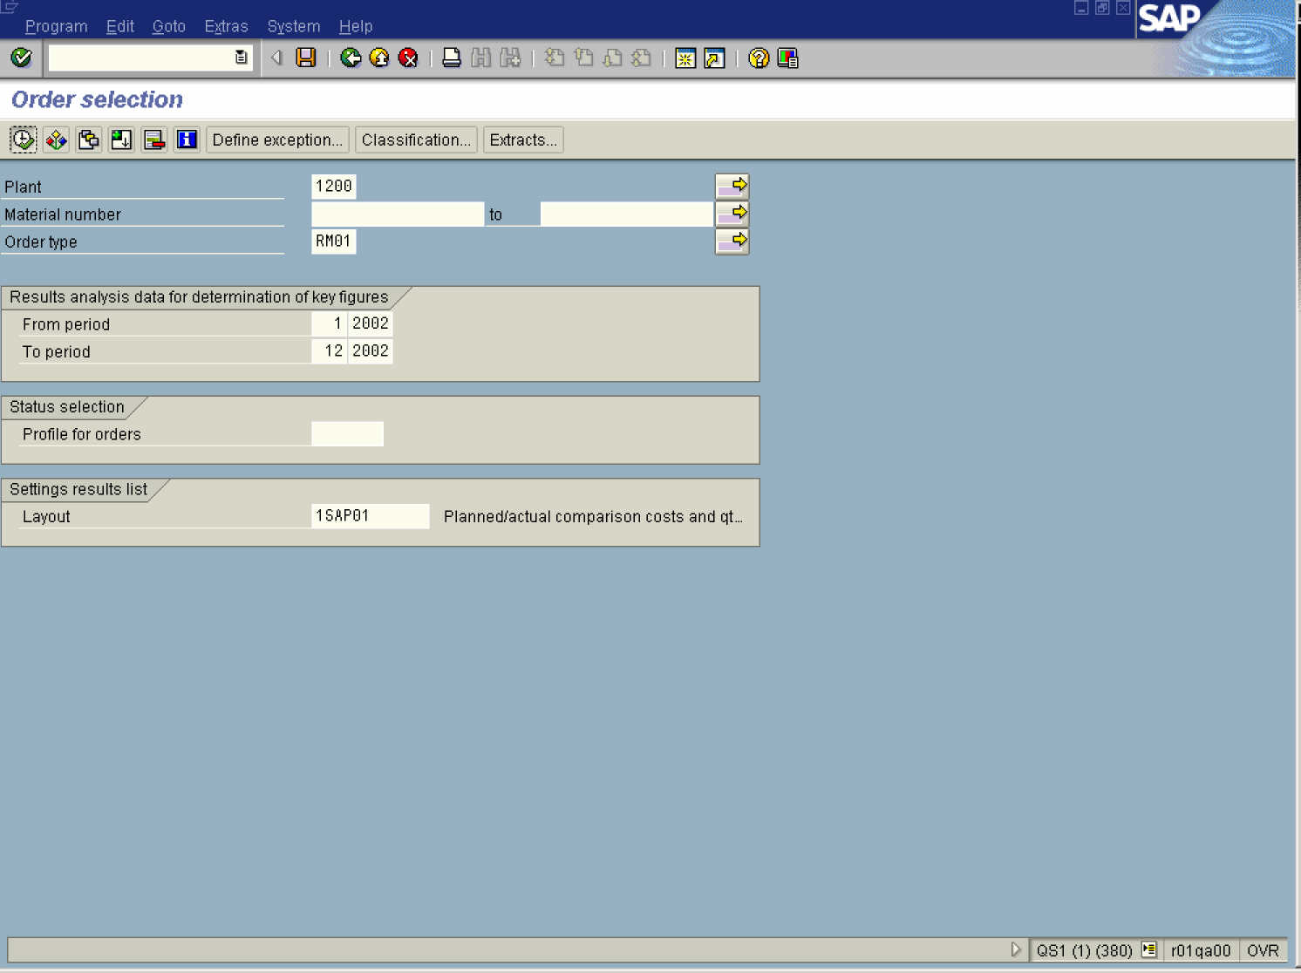

2. Update the following required and optional fields:

Field Name | Field Description | Values
Plant | Code identifying the operational unit of the company where the material is manufactured and stored | Example: 1200
Order type | Description of the Order type. | Example: RM01
From period | Description of the From period. | Example: 01
From year | Description of the From year | Example: 2002
To period | Description of the To period. | Example: 12
To year | Description of the To year. | Example: 2002
3. Click the Execute button.

Order Selection: Results List

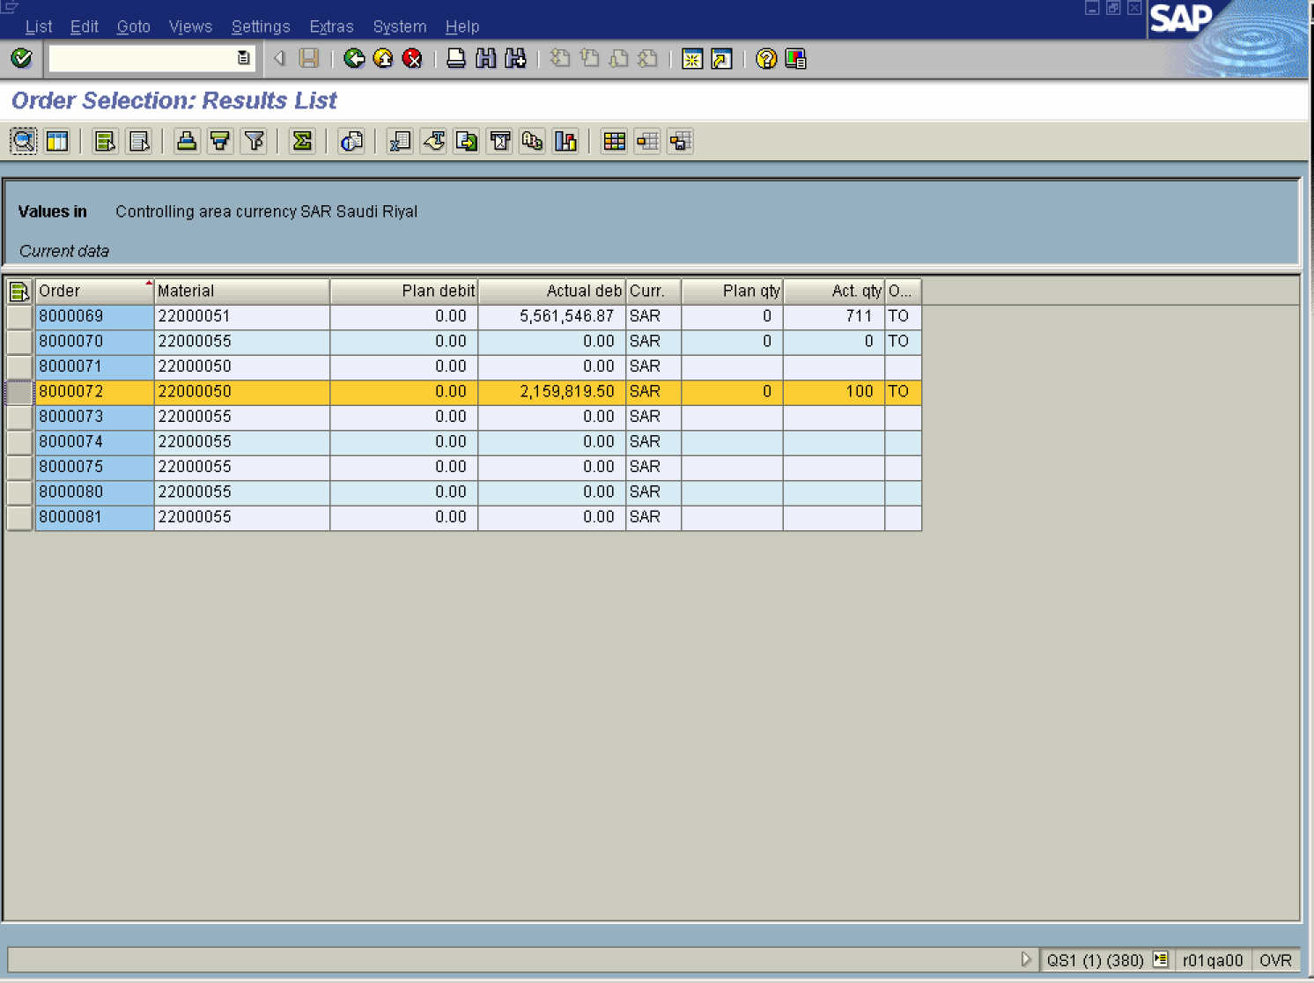

4. Select the 8000072 entry.
5. Click the Details button.

Details

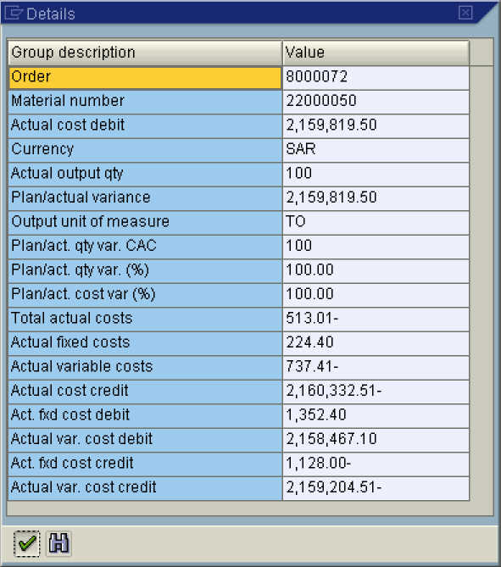

6. Click the Continue button.

Order Selection: Results List

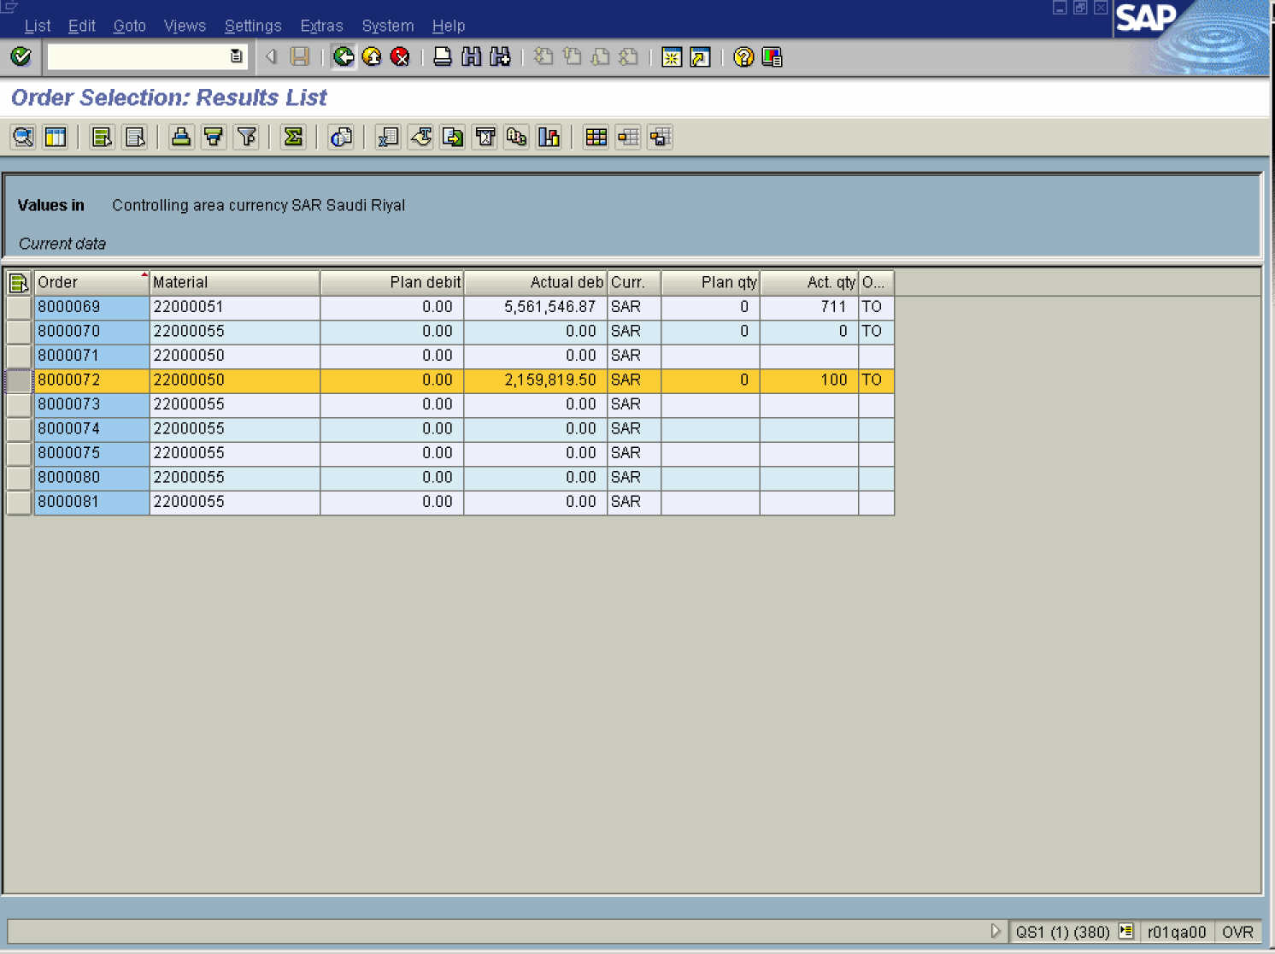

Note: Double click on the cell with relevant data to drill down for more detailed view.

7. Click the Back button.

Exit list

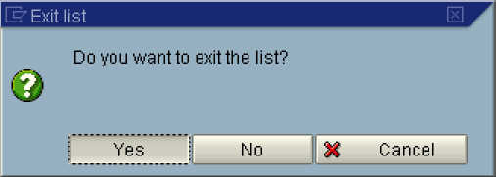

8. Click the Yes button.
Order selection

9. Click the Back button to go back to SAP Easy Access screen.

